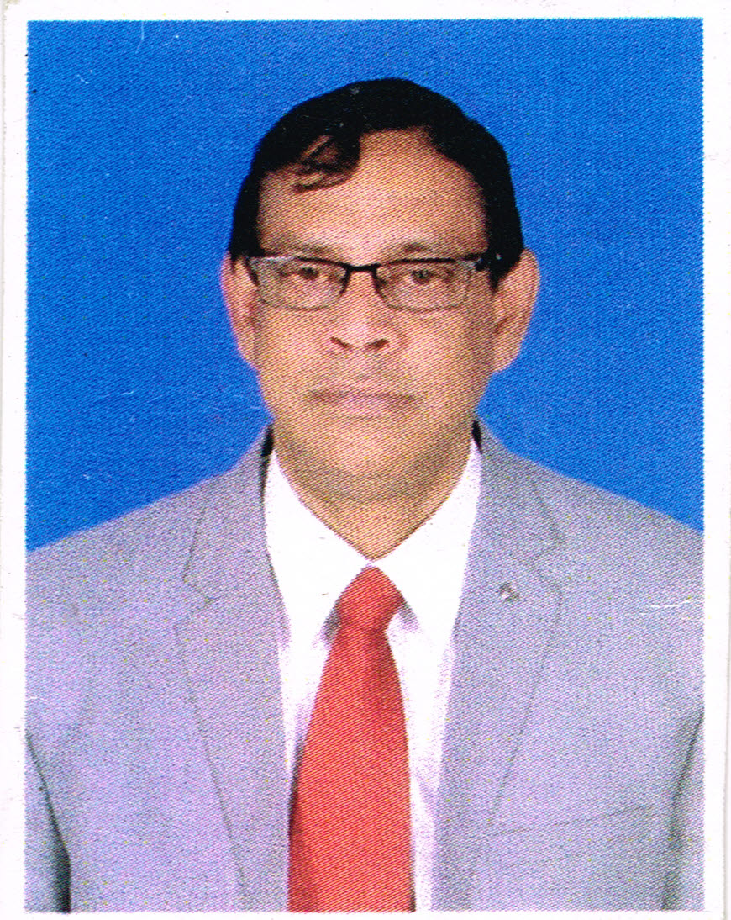

**Kevin James O’Brien**

**🕻:** 075980 75937, 09786 506 421

**🖂:** [kevobrien1960@hotmail.com](mailto:kevobrien1960@hotmail.com)

**Academic Qualification**

* First Class: M A English (Spl. Paper in American Literature) - 1985-Utkal University, India (60.1 %) - Stood first in the University
* Second Class BA Honours (English) with Distinction - 1981 - Utkal University, India (58.6 %) - English Honours, MIL (Alternative English), history - Stood Third in the University. Awarded Scholarship
* First Class Intermediate Arts - 1979 - Utkal University (70.1 %). English, MIL (Alternative English), Economics, Political Science, History - Awarded Scholarship
* Second Division – ICSE - 1976: Stewart School (58.4 %) - Credit in English, Hindi and History

**Publications:**

* **ICSE COMPLETE COURSE ENGLISH I – CLASS IX & X,** *Oswal Publishers*
* **ICSE COMPLETE COURSE ENGLISH I – WORKBOOK FOR CLASS X**, *Oswal Publishers*
* **ISC COMPLETE COURSE ENGLISH II- XI & XII,** *Oswal Publishers*
* **ISC COMPLETE COURSE ENGLISH-I WORKBOOK FOR CLASS XII,** *Oswal Publishers*

**Professional Experience**

* Present Assignment: Principal Vian Veenai Public School, Coimbatore
* Chair, Department of English, Riverside Public School Kotagiri, July 2016 onwards. (Teaching English Literature & English Language for Classes 11 and 12.)
* Chair, Department of English, The Lawrence School Lovedale, February 2015 onwards. (Teaching English Literature & English Language for Classes 11 and 12.)
* Former Assignment: Chair, Department of English, Good Shepherd International School, Ooty, Tamil Nadu, July – October 2014. (Teaching English Literature & English Language for Classes 11 and 12.)
* Former Assignment: Chair, Department of English, The Assam Valley School, Tezpur, Assam from 2005 to 2014. (Teaching English Literature & English Language for Classes 11 and 12. **Received Best Teacher’s Award of Rupees 50 000 in 2010.**
* Utkal University, Orissa - Lecturer in English from 1987-2005. Public Service Commission – Gazetted Officer under O.E.S. (Orissa Education Service)
* Have been guide and supervisor for M. Phil scholars.
* Pursuing my Ph.D on “Walter de la Mare: A Study in Vision and Reality”
* Coordinated Poetry Sessions and Literary Meets
* Course Director, Woodlands Institute, English Language Training Centre (Cuttack, Orissa from 1987-2005) – Language training Centre. (Teaching & training : Reading, Writing, Academic Writing, Communication skills and English Literature)
* Trainer for students, Corporate personnel and professionals in Communication skills
* Trainer’s Trainer for Teachers of ISC in teaching of English Literature and English Language
* Voice, pronunciation and modulation Trainer for Announcing
* Post-Graduate Teaching Experience-Poetry, Drama, Fiction, History of Literature and Criticism
* Under Graduate Teaching Experience-Poetry, Drama, Fiction, History of Literature and Criticism

**Other Experience**

* Announcer for all programmes at college and school level
* Announcer for Lakme Fashion Show, Assam.
* Master in-Charge of Theatre, Debating, Elocution, Creative Writing, Public Speaking, English Literary Journal and Yearbook
* Creative Director, Anchor, Researcher and Script writer for documentary films for the National Television Network. Research, Script, Voice Over and Presentation
* Live compere for programmes and Quiz Competitions
* Announcer for the Annual Rath Yatra (Car Festival) in Orissa and many more for Delhi Doordarshan
* Regular on talk shows-A.I.R.

**Experience (Administrative):**

* Director Woodland Institute, Cuttack, Orissa
* Chairing the largest Department (Dept. of English) at The Assam Valley School
* Panel Member for the recruitment of teaching faculty members

**Further Experience (expert & advisor):**

* National Examiner for Intermediate and Graduation
* National Examiner for ISC
* Attended Council Workshops
* Academic Consultant (English) for CISCE Schools like Heritage School, Kolkata
* Placement Trainer
* Editor of all English journals and magazines of the schools worked in.

**Experience (Theatre):**

* Written and directed plays for college and school in addition to directing plays like Merchant of Venice, Charley’s Aunt, Chandalika, Happiest Days of Your Life,to name a few.
* Awarded the Best Director (English category) in the Inter-State National Drama Competition held at KalaVikash Kendra, Cuttack.

**Strengths**

* Developing skills of motivating students in enhancing linguistic skills and critical acumen in the study of English Literature.
* Communicative skills in English and Hindi
* Poetry, Philosophy and Passion
* To learn to learn and to question a question

**Personal Profile**

* Father’s Name: Late Dr. A P .O’Brien (Former Head of the Dept. English, Banaras Hindu University)
* Nationality: Indian
* Religion: Christian (Anglo Indian)
* Born on: 30th August 1960
* Marital Status: Married
* Address: Door Number 35, Peon Colony, Eachanari, Coimbatore, 641021, Tamil Nadu, India
* Phone: 91-9786506421
* Email: kevobrien1960@hotmail.com
* Hobbies: Creative Writing, Poetry, Music, Reading and Travelling
* Attitudes: Collaborative, Friendly, Transparent, Systematic and Target Oriented

**References**:

1. Dr. Terry O’Brien, Academician, Writer, Quiz master, Motivational Speaker.
2. Mr. Derek O’Brien, Spokesperson, Trinamool Congress, Quizmaster.

**Mr. Kevin James O’Brien**